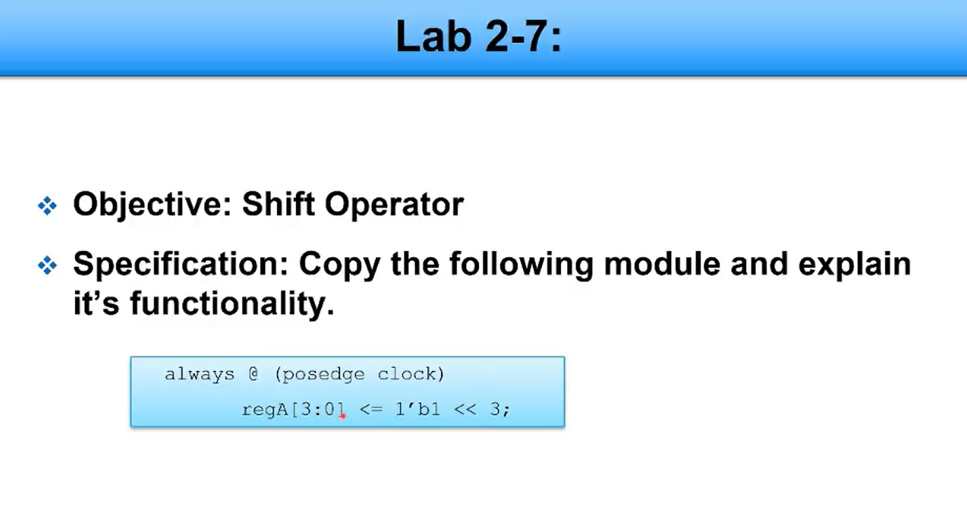
EXPLANATION:
This will shift 1 by left 3(which means it will become 8) and then store the value ins refA.

